

**The Hong Kong University of Science and Technology**

**Department of Mathematics**

**Project Report**

# L1 Trend Filtering

***LI Longxin 20567949***

**Abstract**

The problem of estimating underlying trends in time series data arises in a variety of disciplines. We replicate the work of Kim et al who proposed a variation on Hodrick–Prescott (H-P) ﬁltering, a widely used method for trend estimation. The proposed L1 trend ﬁltering method substitutes a sum of absolute values (i.e., L1 norm) for the sum of squares used in H-P ﬁltering to penalize variations in the estimated trend. Furthermore, the L1 trend filter is extended to a financial scenario where L1 trend filter is used to filter out the noised price fluctuation and estimate the real trend drift of prices. The backtesting result of L1 trend filter shows that the proposed framework is able to predict some drift and control overall risk exposure by reducing the equity exposure.

**Key words:** volatility, riskiness of an asset, L1 trend filtering, Hodrick–Prescott (H-P) ﬁltering

**Contents**

L1 Trend Filtering 1

I. Introduction 4

II. Methodology 5

III. Results 6

Data source and period 6

Exploratory of result 6

IV. Conclusions 11

Reference list 12

# Introduction

Researchers and investors conducted extensive research related to technical analysis for decades in various financial fields and technical trading rules have been treated as one of the effective ways to generate trading signals. Among different approaches, momentum strategy is the most well tested strategy that may generate profit continuously.

Traditionally, momentum investing involves a strict set of rules based on [technical indicators](https://www.investopedia.com/terms/t/technicalindicator.asp) that dictate market entry and exit points for particular securities. Momentum investors sometimes use two longer-term moving averages, one a bit shorter than the other, for trading signals. Some use 50-day and 200-day moving averages, for example. The 50-day crossing above the 200-day creates a buy signal. A 50-day crossing back below the 200-day creates a sell signal. A few momentum investors prefer to use even longer-term moving averages for signaling purposes.

Evolutionary algorithms such as genetic programming allow a system to automatically generate and adapt trading rules according to certain criteria. Genetic algorithms were combined with technical trading rules. Bauer reported that systems built based on genetic algorithms were able to generate positive excess returns in the US exchange market. However, genetic programming was argued to be more appropriate in extracting trading rules from historical data because of its special structure. A flexible framework for adjusting the trading rules to the current environment was presented. With the application of genetic programing to the financial industry, researchers tested its capability of generating excess returns using a data set from different markets and different assets.

Most recently, the filter, a revised version of Hodrick–Prescott (H-P) filtering, is proposed by Kim to extract the estimated trend for momentum strategy by substituting a sum of absolute values ( norm) for the sum of squares used in H-P filtering to penalize variations in the estimated trend. The trend filtering method produces trend estimates that are piecewise linear, and therefore it is well suited to analyzing time series with an underlying piecewise linear trend. By accurate estimation of the price drift, a momentum can be addressed by tuning the exposure between equity and fixed income instrument dynamically.

In this report, we will reproduce the result declared by Kim to make sure the correctness of the framework and then extend the model to an intra-day scenario where 0005.HK and 0700.HK are used as the sample inputs*.*

# Methodology

Following the framework of Kim’s trend filtering, we choose the trend estimate as the minimizer of the weighted sum objective function:

which can be written in matrix format as

where stands for the norm of the vector . As in H-P ﬁltering, λ is a nonnegative parameter used to control the trade-oﬀ between smoothness of x and size of the residual. The weighted sum objective is strictly convex and coercive in x and so has a unique minimizer.

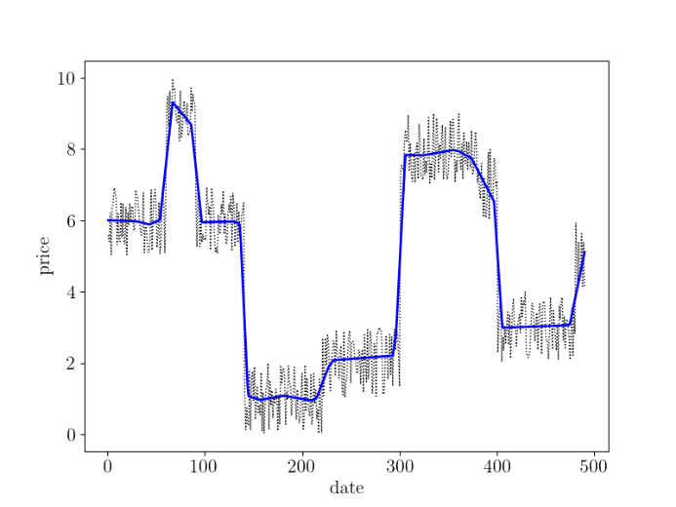

To filter out the noise in the signals like above diagram, we are required to firstly calibrate a proper value of λ. For large values of λ, we obtain the long-term trend of the data while for small values of λ, we obtain short-term trends of the data so we first compute the range of λ and compute the estimated errors within that range of λ. For large value of λ, we remark that there exists a maximum value  given by:

After having the range of λ, we followed the calibration procedures given by Kim to optimize the value of λ.

For back-testing, we used a self-financing model to compute the PnL which is given by:

where is the weight of equities and 1 - is the weight of risk free rate or bond. is the wealth or total capital at time t and is the price of the specific equity. To compute the exposure of equity, we assume the risk-adjusted return can be regarded as the criteria to compute the exposure

and we further consider the strategy as a long/short strategy, that is we impose () = (-1, 1).

# Results

### Data source and period

* Data frequency: daily data and tick data
* Data nature: close price and tick price
* Data source: Yahoo Finance and Andrew’s data
* Ticker: SPX index, 0005.HK and 0700.HK
* Data time period: from 2010/01/01 to 2019/12/01

### Exploratory of result

The first result is the optimal value of λ. Since we strictly followed the calibration procedure given by Kim and estimated the range of λ, we first deﬁne two additional parameters which characterize the trend detection mechanism. The ﬁrst parameter T1 is the width of the data windows to estimate the optimal λ with respect to our target strategy. This parameter controls the precision of our calibration. The second parameter T2 is used to estimate the prediction error of the trends obtained in the main window. This parameter characterizes the time horizon of the investment strategy.

We used the S&P500 index as the reference to show the impact on different values of λ. As shown below, the estimation of L1 filter become more general with the increase of λ value since λ is the penalizing coefficient which is able to impose the estimation more like a straight line if the λ is increased continuously.

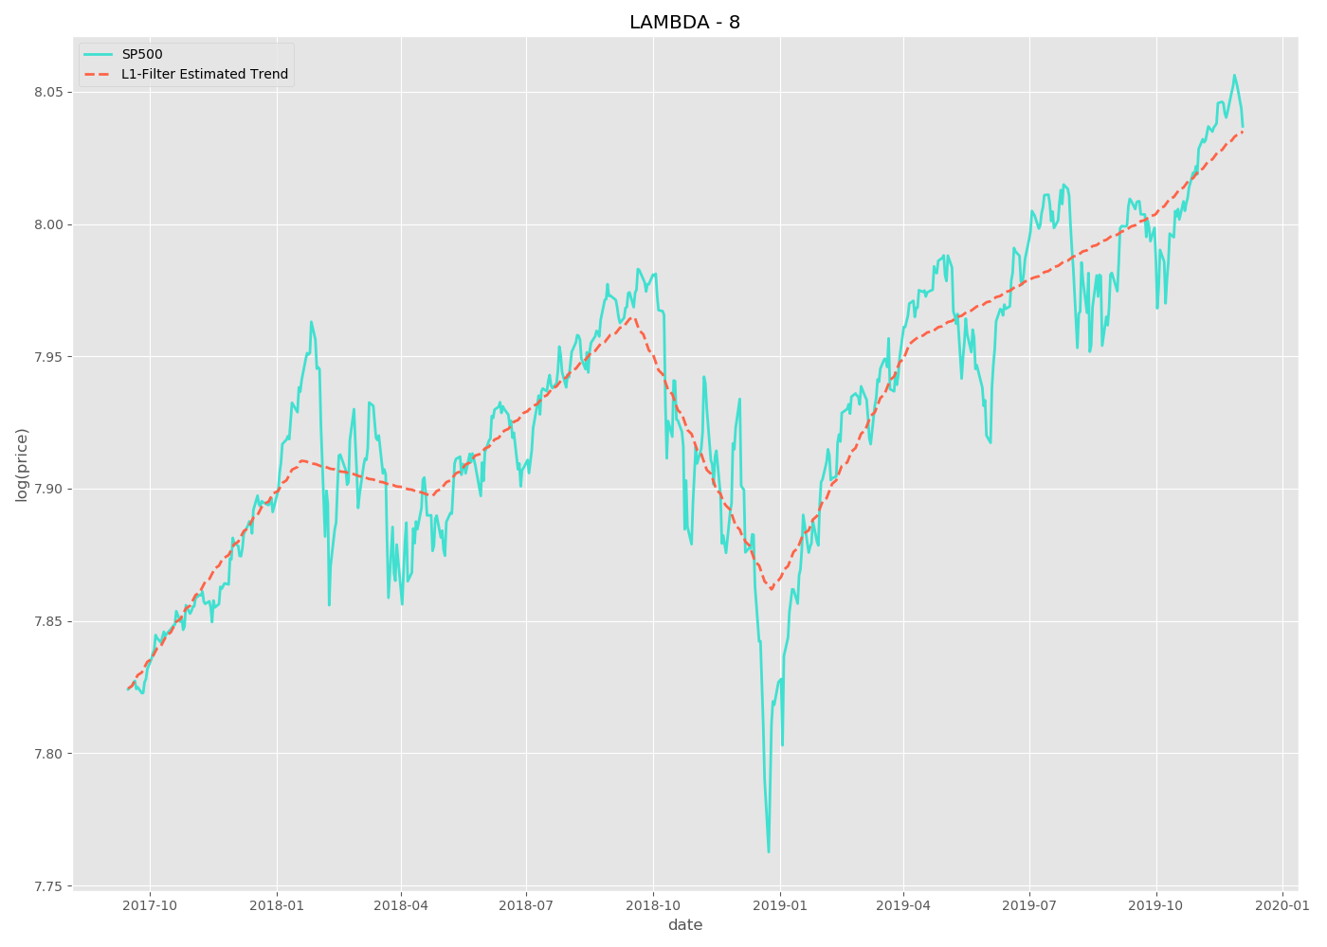

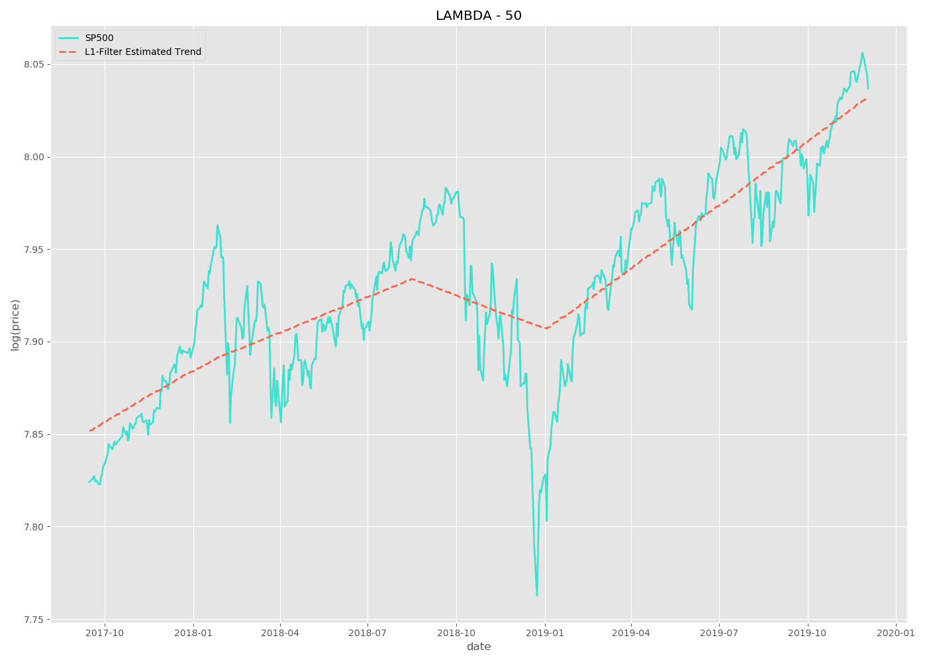

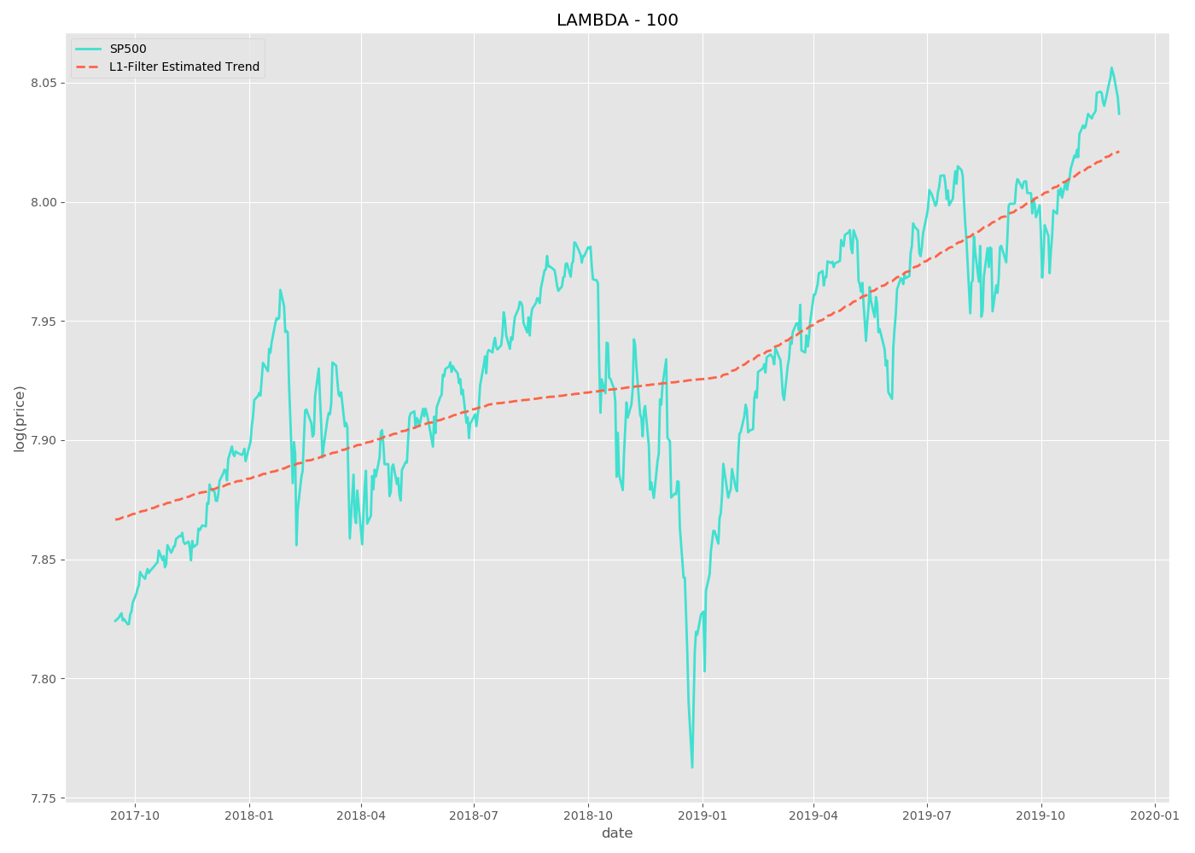

As shown above, λ can have great influence on the estimation result and then we plot the error rate in terms of different λ which shows that the error rate can be minimized when lnλ is close to 2 or λ is close to 8.

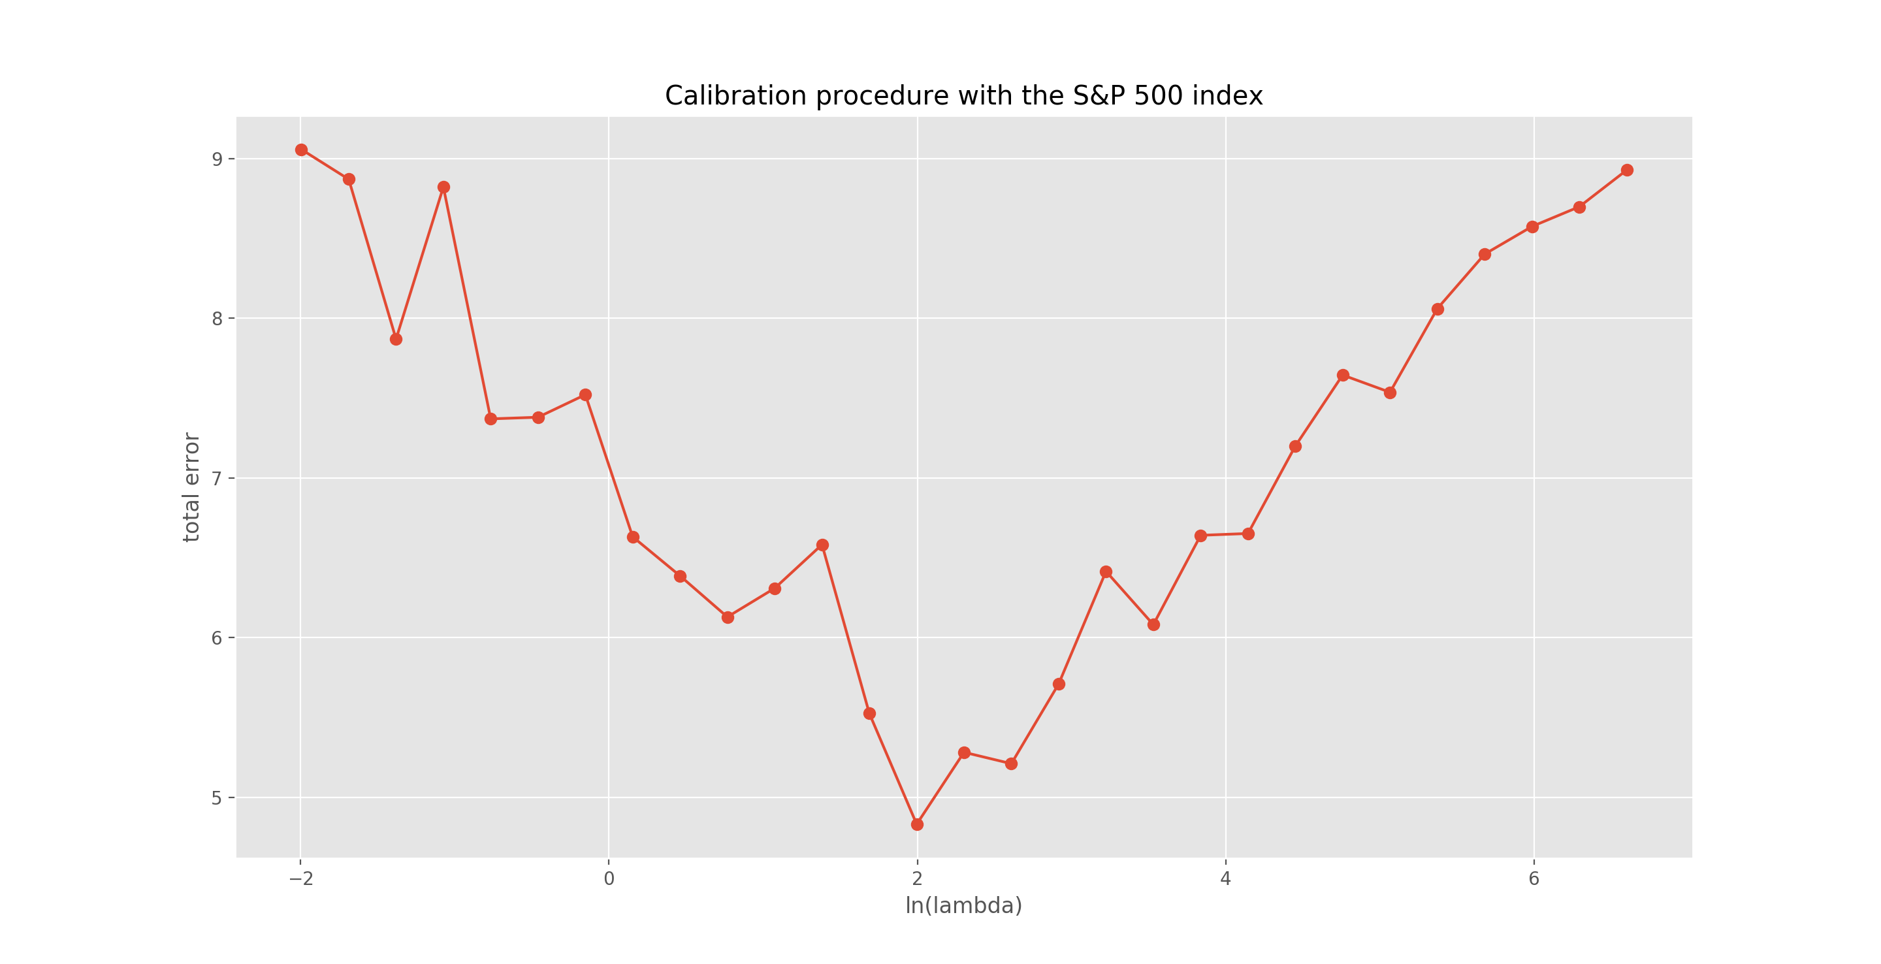

For calibrating the λ of 0005.HK and 0700.HK, we use the similar approach to find out the optimized value and substitute the value into objective function of L1 trend filter for back-testing.

For backtesting of S&P500 index, the proposed framework cannot outperform the PnL of S&P500 benchmark by using the optimal lambda but interestingly, we can clearly see that the overall risk exposure and maximum drawdown have been controlled by the proposed method. As circled part in below, the abrupt drawdown of equity market is compensated by reducing the exposure of equity and increasing the exposure of risk-free rate (assumed 3% annually).

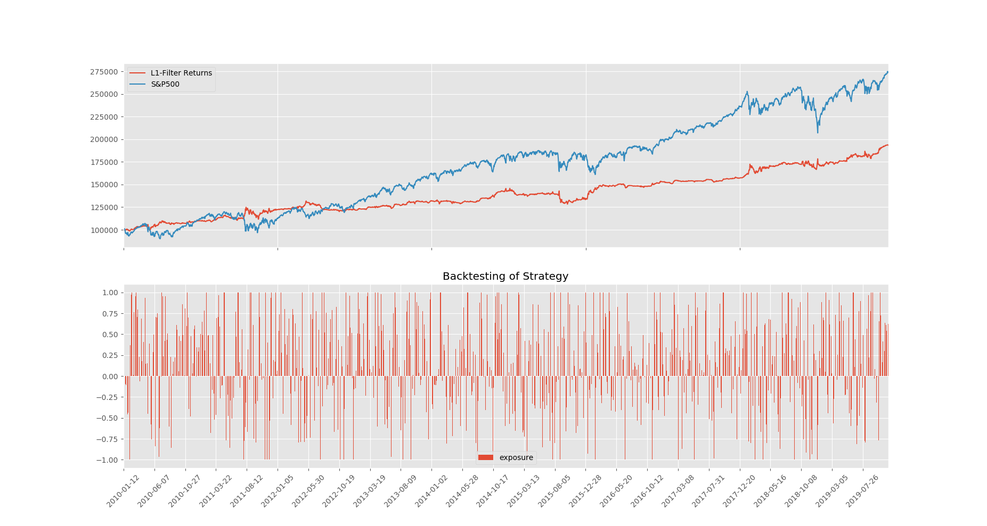

***Figure***. Back-test of S&P500 index. The blue line is the return of benchmark and red line is the return of proposed method. The exposure bar chart is the equity exposure which is limited to (-1, 1)

Similar to back-test of S&P500, we extend the back-test to an intraday scenario by using the tick data of 0005.HK and 0700.HK. Since the original data is the tick data whose timestamp is randomized and irregular, we resampled the data into 1 minute by using the last price as the resampling criteria to regularize the tick data.

Furthermore, we re-design the training and predicting window size of L1 trend filter compared with the original recipe proposed by Kim. Due to the intra-day scenario, we reduce the training and predicting windows to 30 and 5 correspondingly, which means that we are using previous 30 minutes prices as the training data to filter out the trend that is the predicted drift of next 5 minutes for back-testing. The reason why we were doing that is the original recipe using 500 and 50 as the training and predicting windows, significantly deviated from the intra-day scenario since the minute-level prices of a single trading day is around 250 which is far away less than the required training samples of the original recipe.

After adapting the suitable hyper-parameter, we have the following out-of-sample back-testing results of 0005.HK and 0700.HK:

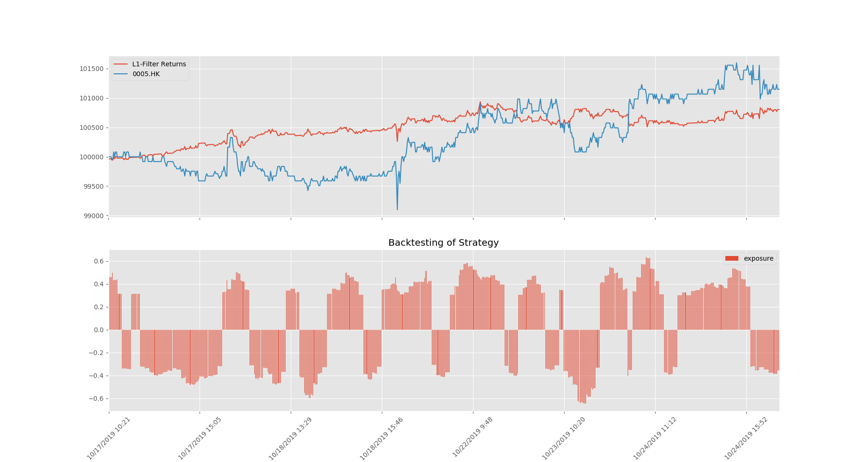

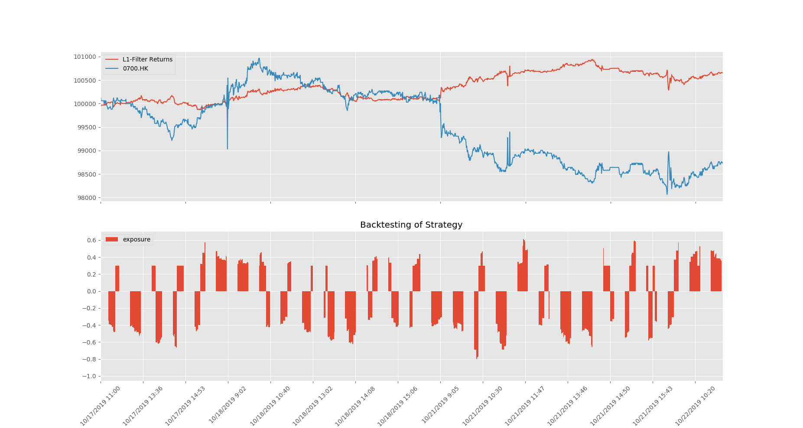

According to the results of above figures, the proposed method can demonstrate more stable performance if compared with the underlying assets. The strategy can quick response to the weird and abrupt change of prices by dynamically adjusting the underlying exposures so the strategy is adept in controlling the risk, increasing the Sharpe ratio and reducing the maximum drawdown. However, the strategy may not react to some low changes of prices or capture some reverting signals.

# Conclusions

In general, the proposed L1 trend filtering method can demonstrate effectiveness while controlling risk and increasing the Sharpe ratio by quickly response of price changes if the size of training window is reduced. With the increasing of size of training window, the L1 filter can capture more long-term momentum of the underlying assets but lack of quickly reaction. For the high frequency scenario like filtering the tick data noise, it is more reasonable and effective to reduce the training window size since the main purpose is to capture the abrupt market change. In the other hand, the long period of training period is suitable and accurate in the scenario of long-term momentum dominated securities like daily prices of S&P500 index.

**Reference list**

[1] Alexandrov T., Bianconcini S., Dagum E.B., Maass P. and McElroy T. (2008), A Review of Some Modern Approaches to the Problem of Trend Extraction , US Census Bureau, RRS #2008/03.

[2] Kim S-J., Koh K., Boyd S. and Gorinevsky D. (2009), ` 1 Trend Filtering, SIAM Review, 51(2), pp. 339-360.

[3] Boyd S. and Vandenberghe L. (2009), Convex Optimization, Cambridge University Press.

[4] Efron B., Tibshirani R. and Friedman R. (2009), The Elements of Statistical Learning, Second Edition, Springer.

[5] Target Volatility to help smooth the Investing Experience (Fidelity, July 2013)

[6] Dao, Tung-Lam. Momentum Strategies with L1 Filter[J]. Social Science Electronic Publishing, 2014.